Logan Anderson-Teddy Roosevelt

Nate Borhcert- Jackie Robinson

C:\Users\gruneike\AppData\Local\Microsoft\Windows\Temporary Internet Files\Content.IE5\37NPKWZ2\MC900353620[1].wmfJadyn Dressen- Jerry Lee Lewis

Micah Fritz- Daniel Boone

Ian Hackett- George Custer

Allison Hegg- Joan of Arc

Danek Hilmar- Thomas Edison

Austin Johnson-Green- Abraham Lincoln

Maddie Kringen- Tina Turner

Kiya Miller- Martha Washington

Carter Nelson- Michael Jordan

Hailey Nygaard- Helen Keller

Riley Nyman- Thomas Jefferson

Kaleb Penning- John Deere

Olivia Prasek- Pocahontas

Colin Rentz- Robert Wadlow

Ella Schmidt- Amelia Earhart

Ashley Snoozy- John Adams

Nychole Steineke- Juliette Gordon Low

Gracie Vail- Grace Kelly

Rachael Vietor- Molly Pitcher

Andrew Weiland- Albert Einstein

Megan Abbott- Walt Disney

Dayton Andersen- Muhammad Ali

Kyle Cavigielli- Neil Armstrong

Caleb Clark- George Lucas

Trevon Cross- Peyton Manning

Becky Dorn- James Naismith

Olivia Downs- Nelson Mandella

Ellie Fiddelke- Leonardo da Vinci

Tate Flaskey- Johnny Cash

Brayden Gee- Steve Jobs

Eli Griebel- Meriwether Lewis

Hanna Hurlburt- Babe Ruth

Mitchell Klinkenborg- Lauri Rapala

Canyon Lowman- Walter Payton

C:\Users\gruneike\AppData\Local\Microsoft\Windows\Temporary Internet Files\Content.IE5\37NPKWZ2\MC900037405[1].wmfZach McKee- John Madden

Justin Nirva- George Bush

Austin Pedde- Elvis Presley

Sam Price- Anne Frank

Katy Pulscher- George Washington

Sadie Schmitt- Chuck Berry

Zach Schreier- Vince Lombardi

Kyra Wajer- Rosa Parks

Hadden Wooten- Benjamin Franklin

Kenzie Apland- Queen Elizabeth

Lucas Berg- Franklin Roosevelt

Kathryn Fletcher- Princess Diana

Mitchell Geraets- Davy Crockett

Peyton Gleason- Dr. Seuss

Cameron Greeley- Christopher Columbus

Taylor Hansen- Cleopatra

Brady Larson- J. Edgar Hoover

Megan Lauritzen- Laura Ingalls Wilder

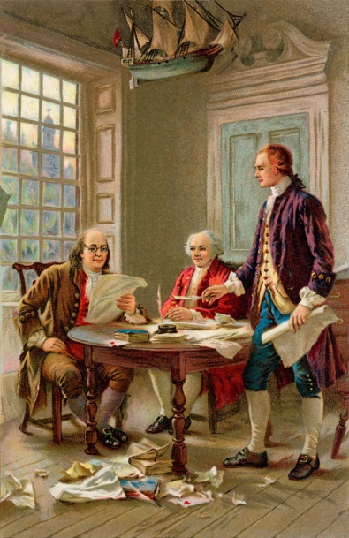

The 5th graders would like to thank you for coming out today to show your support!

Asher Lensing- Jerry Rice

Jakob Letsche- Martin Luther King Jr.

C:\Users\gruneike\AppData\Local\Microsoft\Windows\Temporary Internet Files\Content.IE5\WP4M094N\MC900370390[1].wmfCoby Maeschen- John Wayne

Connor Rentz- John F. Kennedy

Lincoln Richeal- Lou Gehrig

Sami Schmidt- Jane Goodall

Teri Schoeberl- Oprah Winfrey

Logan Schrad- Robert Bayden Powell

Cody Schultz- John Lennon

Trystan Stahl- Jesse James

Natali Vlietstra- Sacagawea

Maddy Wilber- Molly Brown